**IFT 458/598: Middleware Prog & Database Security (Fall 2022)**

Saurabh Verma

Module 3 Assignment Data Format

Instructor: Dinesh Sthapit

September 24, 2022

**Module 3 Assignment Data Format**

**Steps performed while implementing this assignment:**

Reusable components to create a composite component: 1

I made a new project folder and created a package file:

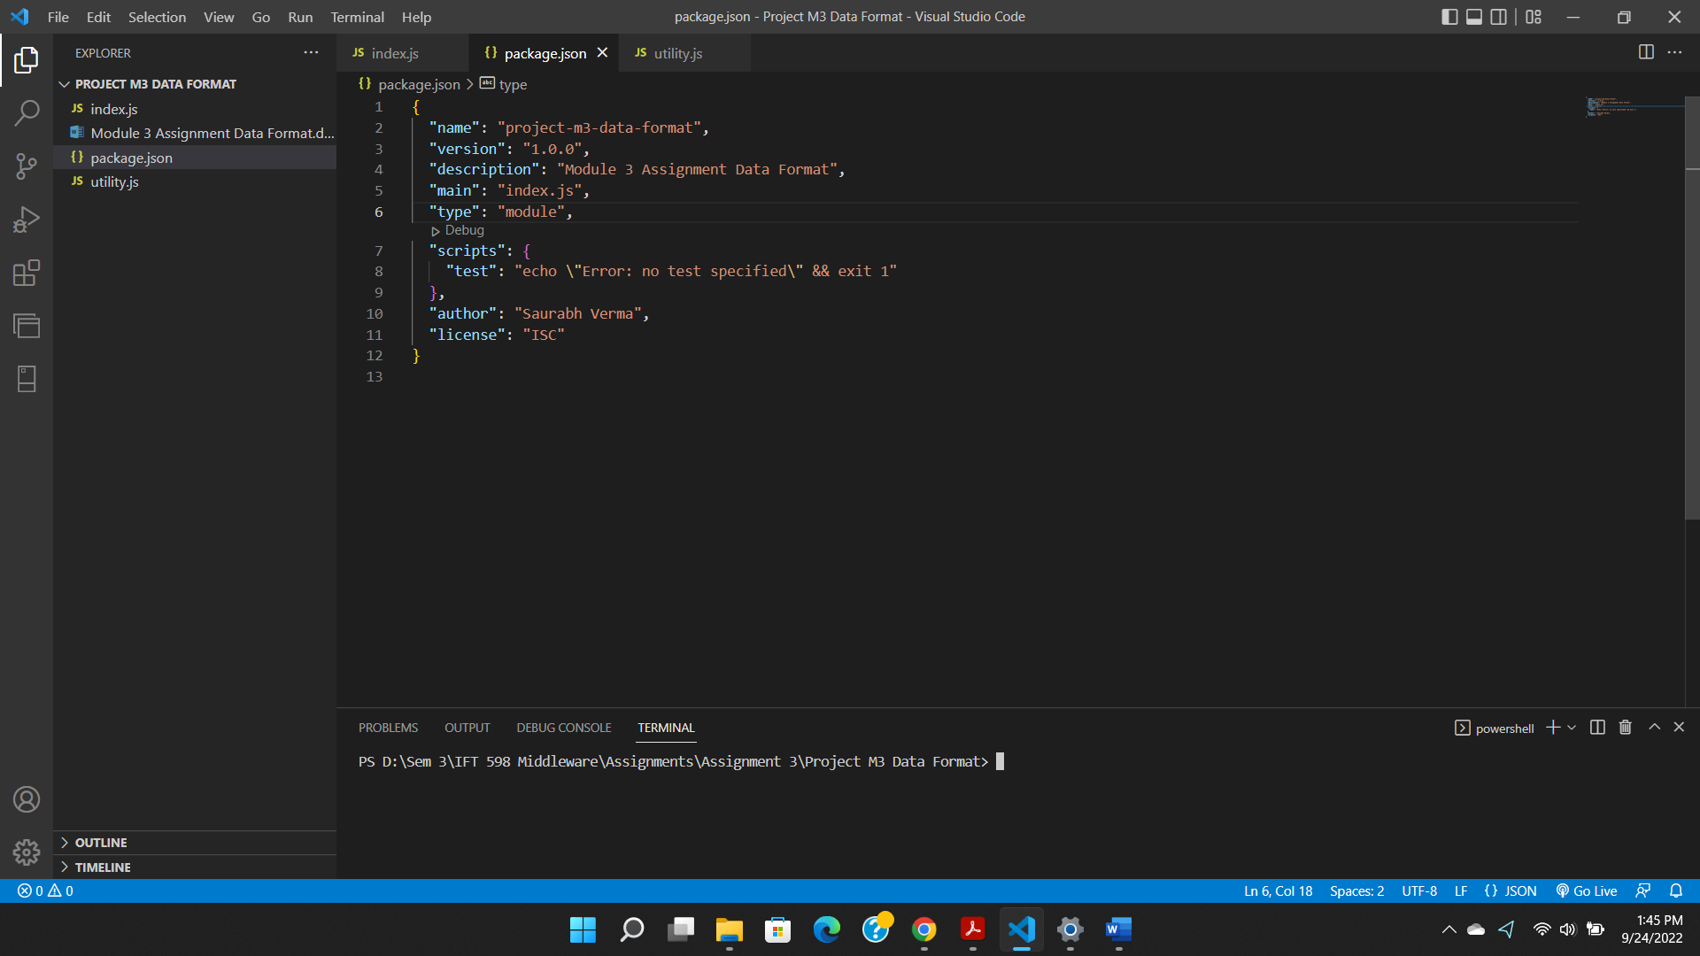

Then I created a JS file called utility and defined a function in it:

Then in the index file, I imported utility.js and called the function:

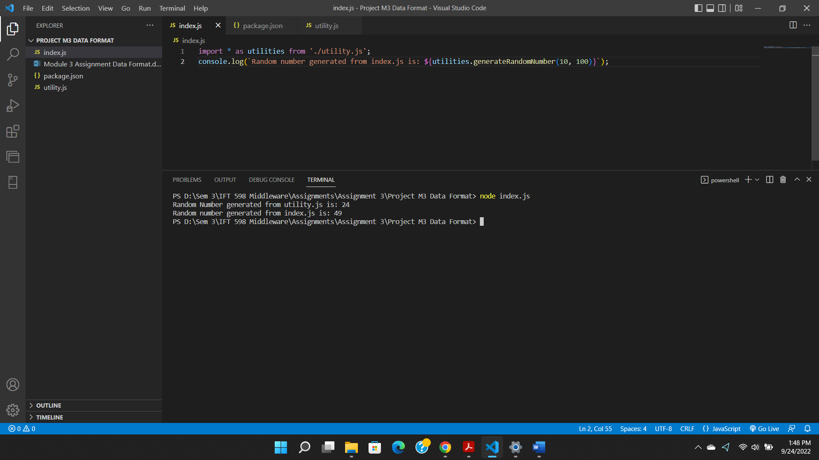

Using Importing External Modules (third-party modules):

Data file exported from a website and copied:

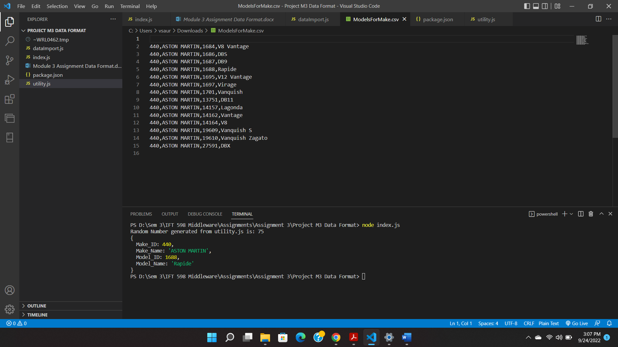

Also created a variable data and stored the above data in json format:

Data Formats and Data Exchange:

Fetched data from a URL and logged it in console:

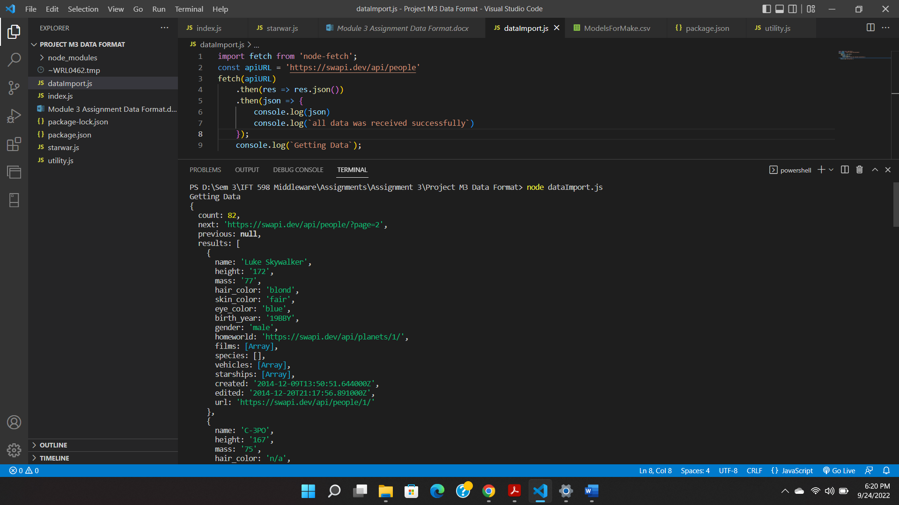

Content Negotiation

Created a file called contentNegotiation.js to get data from an API:

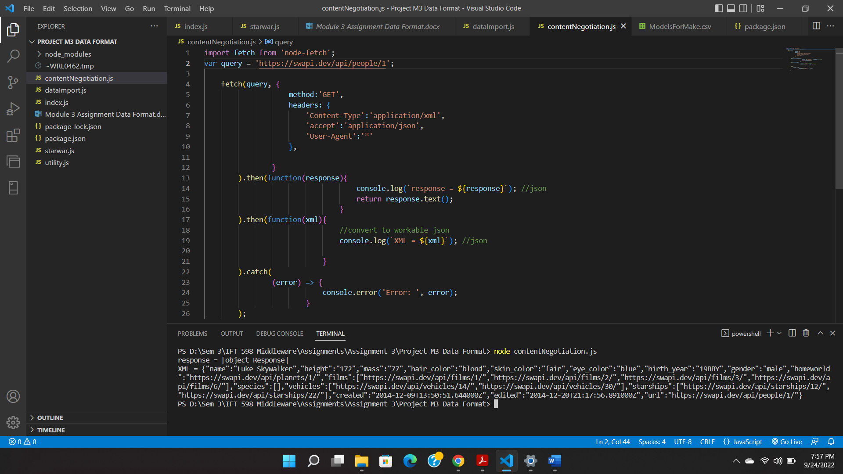

Another output:

**References**

Data file:

<https://vpic.nhtsa.dot.gov/api/vehicles/GetModelsForMakeId/440?format=json>

GitHub repository: